Tesoro Community Development District: May 2023
The Tesoro Community Development District (CDD) has been active in improving the preserve areas over the last year and a half. It is our intention to update residents a few times a year on the progress and projects in short notes. In this first communication we also add the background of the CDD status and operation as this is different from other Tesoro operations.

Background of the Tesoro CDD
The Tesoro Community Development District (CDD) is a special purpose government entity created to own and maintain common area property in the boundaries of the CDD. It has a five-member elected Board of Supervisors, which establishes policy and budgets in accordance with Florida Law. The Board, by law, must hire a District Administrator to oversee the CDD, which in our case is Governmental Management Services. For a history, budgets, audits and other aspects of the CDD refer to Tesorocdd.com

To give a perspective of the relative sizes of the operations in Tesoro, the two golf course areas, the POA housing area (excluding berms), and the CDD areas are roughly the same size, so this CDD is of a significant size and undertaking. It must be noted that the CDD areas are maintained under state permits, so that homeowners cannot undertake clearing, or trimming, or planting in these areas.

Clearing and Trimming
After nearly 13 years of minimal work, in 2022 we managed to find some reserves and start improving our areas. The work involved removing the invasive species, trimming the trees we need to keep and clearing much of the underbrush so plants can grow. We cleared the large mitigation waterway that runs from the east side boundary to the south of Tramonto to the west side and then back under Via Tesoro near Via Casarano. In 2023 we have continued the clearing of the waterway past hole #9 of the Palmer course and to our boundary at the fork of the St Lucie River in the northeast corner. We are also clearing the other waterway we have, called Tomato Creek, which runs on the east side. This opens the waterways and also helps to make the areas behind the lots and homes on the east side more attractive.

This is an ongoing task to maintain these cleared areas, but the advantage is these areas bring spectacular views, birds and wildlife which is now visible. The photos below show the mitigation water around holes #6 and #7 before and after clearing to show the impact of the work.

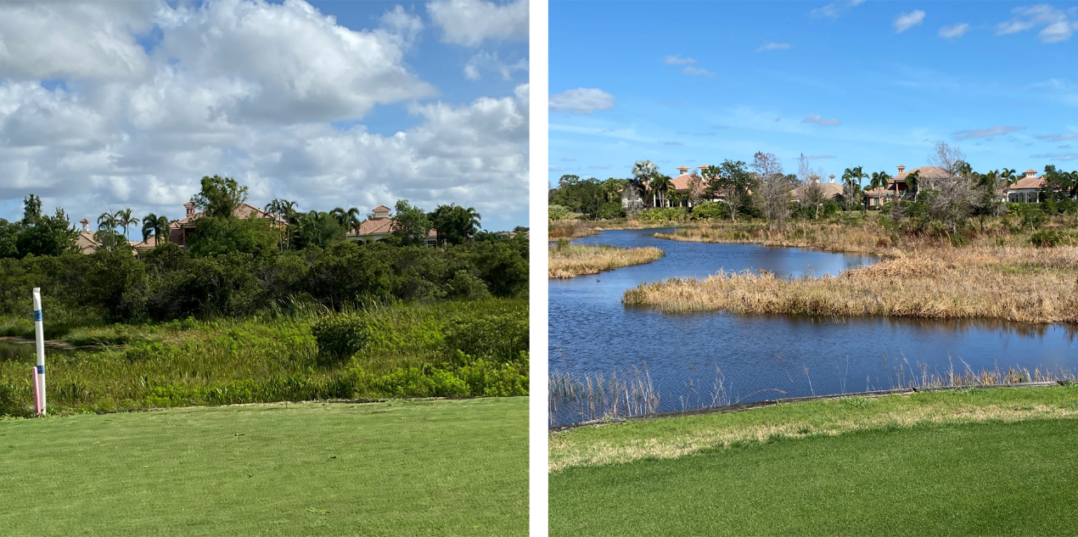

Hole #5 Waterfall
This was non-operative, and we have refurbished the pump and its electrics, rebuilt the retaining wall and the outflow areas, and returned the waterfall and its associated pond to full operation. This area now provides a special area for a plant nursery and birds.

Treatment for algae
Over the last year we have essentially brought the red algae and other algae that clogged our waterways under control, so the water is clearer. The photos below show the same waterway in 2019 and in 2022.

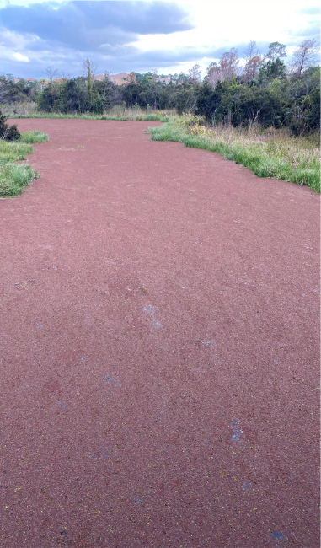
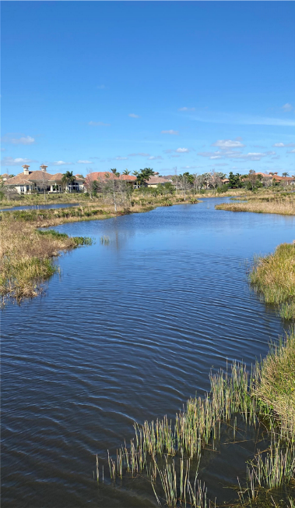

Aquatic flowers
A number of lakes on the west side have special shallow areas, called Littoral Shelves, designed into the water which provide areas for aquatic plants to grow. These have not been maintained and plants have grown unchecked. These shelves are currently being thinned to remove unwanted plants and replanted with natural aquatic plants. We will see how the varying water levels between seasonal no rain and the rainy periods affects these plants, and which thrive, or do not, in our water.

Weir Gates for level control
The lakes in the northwest corner of the property have two weir walls which maintain the water level in these lakes. One wall allows water to feed to the large lake north of the clubhouse, the other to a creek which runs into the St Lucie River in the northeast corner. These levels have been controlled by the CDD which had a piece of plywood installed in a gap in the walls, which was removed if a storm or hurricane was imminent. This is unsafe and crude, and new gates will be installed so the water flow can be controlled professionally. This has to be approved by Port St Lucie who own the walls but this process is nearly complete and will be followed by the manufacture and installation of the new gates.

