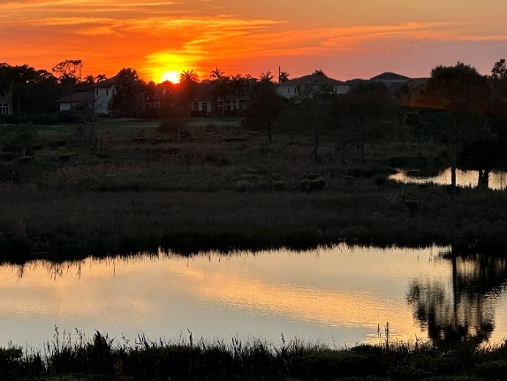
Tesoro CDD

2026 Q1 Community Note

Introduction
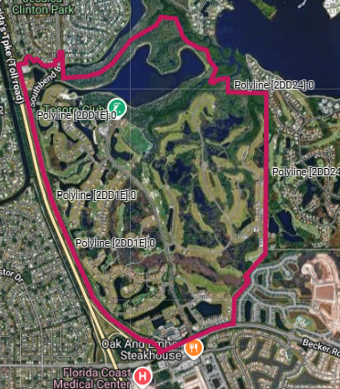
The last few months have been very interesting for the Tesoro CDD, once again! Besides our normal maintenance work and projects, we have some focus from the Florida Department of Environmental Protection (FDEP) on the St Lucie River which requires considerable work.

For the new members of Tesoro, a quick recap of the entities within Tesoro is valuable. Tesoro Club is a private social and sports club; the Tesoro POA administers the areas where there are homes and roads as well as the berm around Tesoro; and the Tesoro CDD is responsible for all the lakes, water flows and preserves within the Community. Each of these have around 33% of the area of the total Tesoro. The CDD encompasses, by state promulgation, all of the Tesoro Site, but the Tesoro Club and Tesoro POA are then given separate entities within the permits.

Retention Ponds
We have started the refurbishment of the retention ponds along Calmo Circle. The drainage there is from the homes towards the street and then from the gutter in the street via storm water drains into a retention pond behind the wall bordering the homes. These ponds have a designed overflow system which means in heavy rain the water will build up there. This will slowly dissipate into the ground and then into the preserves, slowing the water and allowing sediment to settle. If the water flow is really heavy it will overflow into the preserve areas, but only after settling occurs. These are the first line of water quality improvement along many of our streets. We chose Calmo as this has the highest density of homes, which increases the flows from roofs and hard-standing towards the road.

Their condition was poor, as the photos show, and offer little of the retention capability we require.
The photos depict as they were some months ago, then after cleaning the rough outline of the basin and the overflow structure. The last 2 show the recreated basin and the cleared grate which allows the water from the roadway to enter the pond.

Prior Condition After Cleaning
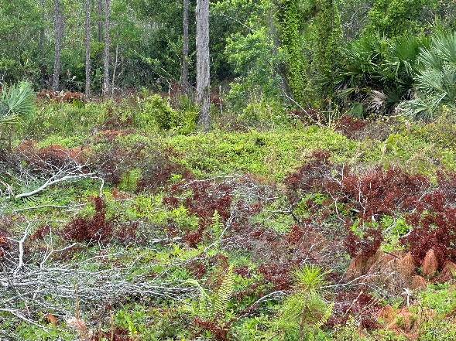
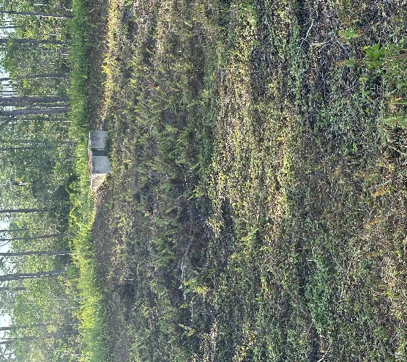

Remade with inlet grid Walls and Overflow structure
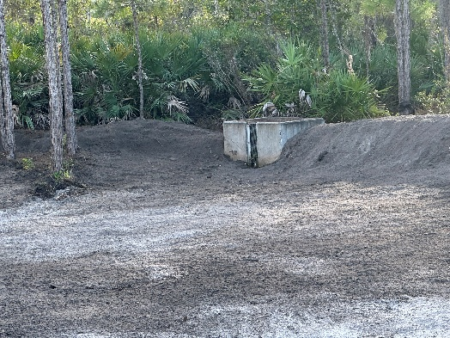
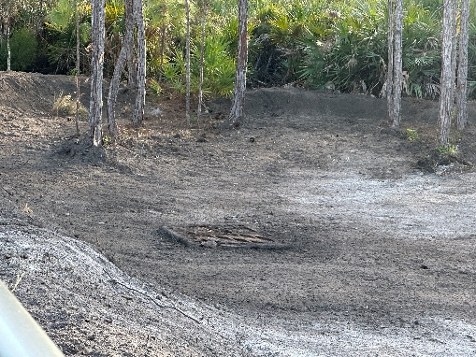

The first 2 ponds have been rebuilt. The walls have been remade and the floor of the pond dug down to the correct depth, after removing all the last 15 plus years of silt and debris. The earthen berm walls are left to settle and in the coming month or so, weather permitting, we will grass the walls and hydra seed the base. This will turn this into a permanent retention capability for the future. We intend to do maintenance on these regularly to ensure these remain in good condition, which is very different from the process of the last 15 years. This is not an insignificant amount of work or cost, and there are well over a dozen of these areas that require attention of some sort, from rebuilding to improving walls for example. This is another essential project and cost.

Rain and Water Levels
I never thought I would look at the Farmers Almanac, but with the absence of rain for so long I might need to borrow one! The lack of rain has the lakes at really low levels, and is exposing many of the plants at the edges and in the littoral shelves. The hope is that we get good, steady rain to bring these water levels up without going from extremely low to extremely high levels and further stress on the plants.

Maintenance
The regular maintenance schedule continues, although it is altered slightly as the lack of rain and the cold snaps have altered growing patterns. Of course, as the water recedes in the lakes, the algae is exposed and blooms. Ronnie Howell and his team from Native Lands have done a really great job in keeping up with the maintenance as well as the algae.

Palmer Hole #18
The area between the weir wall at Hole #10 T-box and the hole #18 T-box was cleared last year and is looking great with open waterways. This work was continued along the northern edge of the hole #18 fairway, and it has opened out the air flow as well as making the area far less like a jungle. All the invasives were removed as well as required by our permits. Of course, every 2 months or so we need to go back and trim the new growth of the smaller trees and shrubs that are suddenly now given sunlight and the ability to grow. These are repeatedly trimmed and the area is covered in wood chips so as to keep the weeds down. There are still a few more cycles to make this a finished area.

Watson Course and East Side Lakes

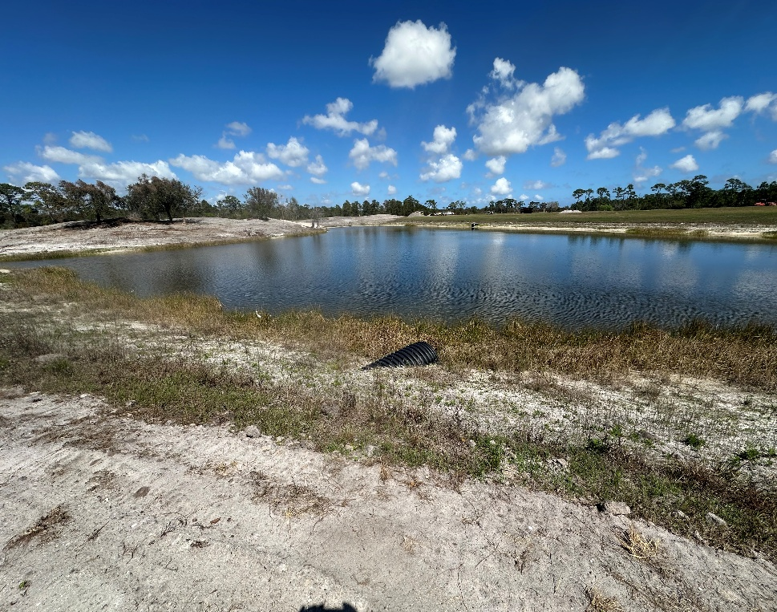
The great news of the restoration of the first 9 holes of this course is another area of work for the CDD. The team doing the work under Jon Beckman is extremely careful that the work doesn’t affect the CDD areas, and that runoff is absolutely minimized as they turn this into a great new facility. Buried in these areas are a number of lakes which have had no work done since this area was developed in 2010. To match this new course the CDD will have to clean the edges of over 15 years of growth by hand, and then later we will plant some new aquatic plants in the corners to start the process of beautification. As the photo shows, these lakes are a long way behind the lakes we have cleaned and done planting elsewhere.

Clean Water Act and BMAP (Basin Management Action Plans)

The Clean Waterways Act of 2020, is Florida's major legislative effort to strengthen water-quality regulations. It targets nutrient pollution into rivers and lakes. This Act has led the Florida Department of Environmental Protection (FDEP) to review all the waters in Florida. They have created a model over an extensive period which helps to predict which areas cause the largest unwanted discharges into river or lake waters. The primary focus is on the amount of Nitrogen and Phosphate (as well as numerous other measurements), which are really a broad measure of fertilizer and ground chemicals which can run off the land into the water. Each of the major basins or areas that are of concern are designated as requiring a BMAP. The St Lucie River has been included as an ‘Impaired River’ which requires attention. The areas such as the city and all the CDD’s discharging into the St Lucie river -north and south forks- have been given targets to reduce their discharge. The model has the Tesoro CDD with a notable discharge due to the size of the community and because of the 2-golf courses with homes, although no actual measurement exists in the FDEP data. The FDEP did try to take samples some 2 years previously, but the chosen position was set right beside the alligator nest on the north side of the Hole #18 waterway. Prudence at the time resulted in no measurement being taken!

We were required to submit a non-binding list of potential improvement projects to the FDEP within this BMAP. The immediate focus is on education (the 100-page Model Golf Course Maintenance manual has been given to the Director of Agronomy for example). We may well have to undertake more definitive changes if the water we discharge is actually a problem. To determine the actual water quality, we have started to take water samples for analysis at select critical points each quarter. Another cost, unfortunately, as these are not cheap!

Conclusions
The work continues to develop and improve Tesoro. Some of the work such as the lakes on the east side in the area of the first 9 holes of the Watson Course will have to be brought forward in time to this year. The sampling and water quality is something we will have to work through with the FDEP to determine what we must correctly and realistically do to protect our water discharge.

CDD Board of Supervisors


John Vogt
Chairman
Rosemary Jones
Supervisor
Michael Ferrucci
Supervisor

Allen Borden
Vice Chairman
Emily Jones
Supervisor

